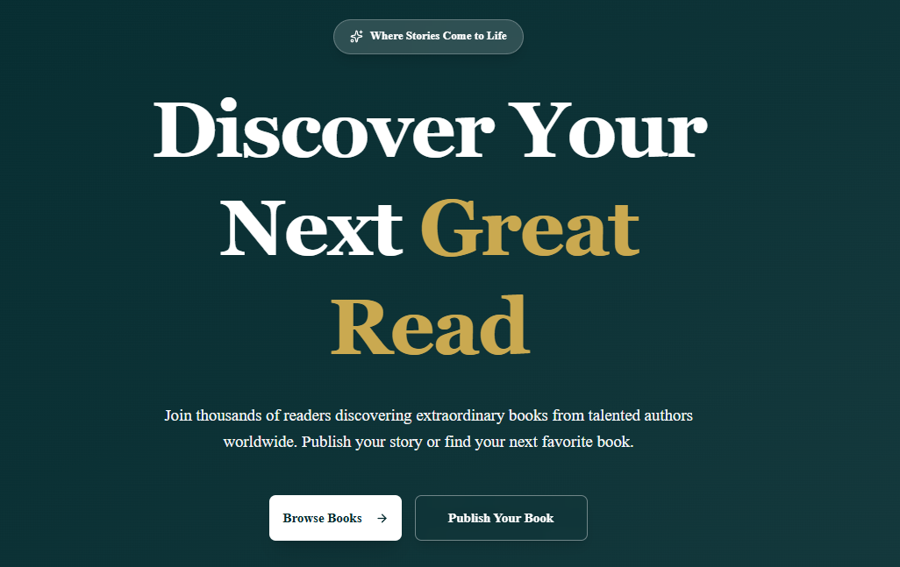
Remove the above small where stories come to life
Main tagline –
“You write, we print.
You dream, we publish”
Tagline:
Explore inspiring books from talented authors across multiple genres, or publish your own masterpiece with HarGlim Publishers. We make reading enjoyable and publishing effortless.
Buttons are good. Keep it as it is
About us:
30+ Books Published
25+ Happy Authors
5+ Countries Reached
Remove awards & recognitions

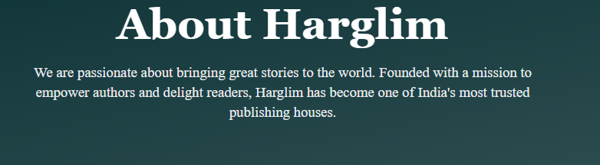
HarGlim – Spelling
HarGlim Publishers was born from the belief that no dream of becoming an author should be left unrealized. We exist to empower beginner and emerging writers who often face challenges in finding publishing opportunities. By providing professional guidance and end-to-end publishing services, we help transform manuscripts into published books and dreams into reality.

Our Story
Founded in 2025, HarGlim Publishers was born from a simple yet powerful belief: every aspiring author deserves an opportunity to become a published author.
We recognised that many talented writers, especially first-time authors, struggle to find trustworthy and affordable publishing support. Despite having inspiring stories and valuable ideas, countless manuscripts remain unpublished because the path to publishing often feels confusing, expensive, or out of reach. We provide end-to-end publishing solutions that empower authors to confidently share their work with the world.
Today, HarGlim Publishers continues to grow as a trusted partner for emerging and established writers alike. Every book we publish represents a dream fulfilled, a voice amplified, and a story brought to life.

Make sure Harglim spelling is correct everywhere – “HarGlim”

Hope this is accessible from admin
Meet Our Team
Photo this much small only
Sunkarapally Sai Teja
Founder & CEO
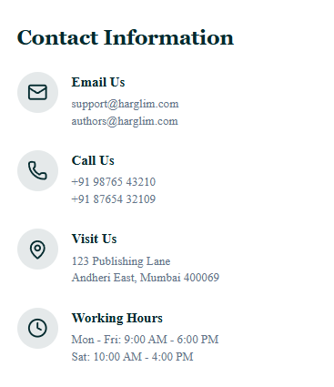
Hope this is accessible from admin
harglimpublication@gmail.com
harglim.support@gmail.com
9392346914
GSP Towers, Beside ESI Hospital Metro Station, Metro pillar no: 1008, Opposite TIMS, 500038, SR Nagar, Hyderabad, Telangana, India
Working hours
Mon – Sun: 9:00 AM – 10 PM

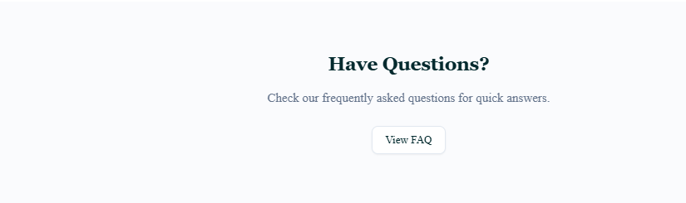
Q: What should I include in my book proposal?
A: A strong proposal includes a query letter, a synopsis, a chapter outline, your author biography, and the first three chapters of your manuscript.
Q: How long does the review process take?
A: Our editorial team reviews proposals within 8 to 12 weeks. If we are interested in moving forward, we will contact you or your agent directly.
Q: Are your books available as both print and digital copies?
A: Yes, we publish our titles in paperback, hardcover, and multiple e-book formats (including EPUB and PDF).
Q: Where can I buy your published books?
A: You can purchase our books through all major online retailers like Amazon, Kindle, Kobo, Apple Books, +12 international platforms. You can also order directly on our Company Website.
Q: Do you offer international shipping for physical books?
A: Yes, we ship worldwide. Shipping rates and delivery times depend on your location. You can calculate your shipping cost at checkout.
Q: How do I request permission to use an excerpt from one of your books?
A: Please submit a request through our Permissions Portal. Provide the title, author, ISBN, and the specific text you wish to use

